Building a Robot

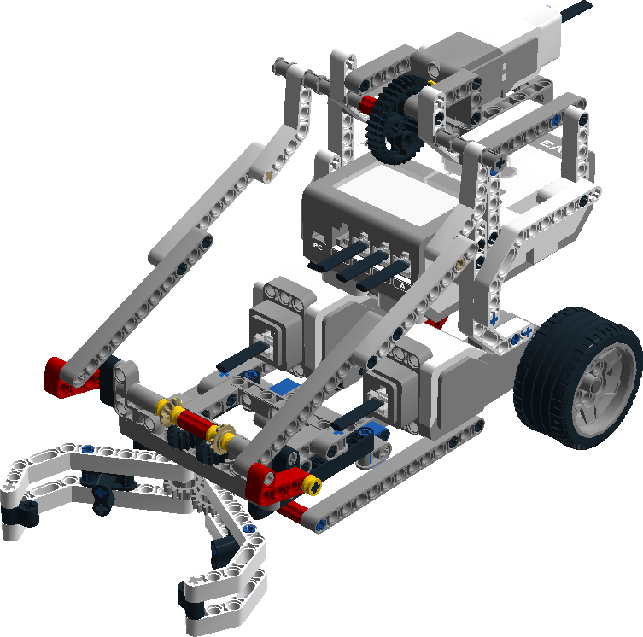

Date: 18-11-2016  
Version 1.1

Student Name : David Hooi Student Number: 3587460

Student Name: Jerique Hodge

Contents

1. Introduction 3

Overview assignment(s) week 2 3

Picking up the Box 4

2. Lego Mindstorms 5

3. Assignment (Drive system) 6

4. Assignment (Pickup system) 8

5. Using the motor(s) 10

6. Perceiving the world. 11

Appendix A: Motors & Sensors 12

Appendix B: Track 13

Appendix C: Lego Mindstorms IDE 14

# Introduction

In Fundamentals for ICT Students (block) 2 you get to build your very own AGV as a proof of concept; hence forward we will call it a robot! In the practical lesson of last week, you have worked on a business case. The goal of this case is to develop the proof of concept that can pick up and deliver containers from point A to point B.

Today you will look at the technical part, building the robot and writing the code for moving the parts of the robot. The structure of this week’s practical will be as following:

* Mix the group so you start working with another team member;
* Think about and create one part of the robot;
* Connect the brick and write a simple program in Lego Mindstorms IDE;
* Think about which sensors you need for the entire robot.

## Overview assignment(s) week 2

**Deliverable:** This document with the answers & one part of the robot working with the brick.  
**Deliverable per**: 2 Students.  
**Deadline:** Week 4; you will show it to the teacher during class.

Building a real AGV is expensive. To convince the CEO of his company mr. Doe’s wants to start with a Lego Mindstorms proof of concept. If this proof of concept proves that it is possible for a robot to pick up the product, move it safely through the warehouse, and drop it off at the drop-off area, he will agree to take the next step and develop a prototype.

Your group is tasked to create this proof of concept. It is your choice as a group if you want to design your own robot, or use the template as shown on the title page. However, to make sure you get acquainted with Lego Mindstorms, this week you will follow one of two tutorials in pairs. See the table below with title “Group”.

|  |  |  |  |
| --- | --- | --- | --- |
| **Group** | | | |
| Pair 1 (Drive system) | | Pair 2 (Pickup system) | |
| Student 1 | Student 2 | Student 3 | Student 4 |
|  | | C:\Users\888602\Dropbox\FIS\Sharepoint\Block 2\Practical\Robot assignment\Grabber With Frame.png | |

Start by switching partner with the other pair in your group. One pair will work on the Drive system the other pair on the pickup system. This means that from your week 1 pair, you will have a drive system expert and a pickup system expert after following the tutorials.

The drive system will make it possible to reach the product, and (after picking it up) reach the destination. The Pickup system will allow the robot to pick the product up, lift it up, and (when the destination is reached) place the product back on the ground and release it.

These two systems can be combined later to make one robot (shown on the title page). As mentioned above, your group has the choice (after completing this tutorial) to create your own robot prototype instead.

Keep in mind that if you want to design a robot yourself, it will require **more** time. This is at your own risk. Make sure that your other subjects don’t suffer by this decision!

## Picking up the Box

Now that you have read the introduction, and understand what is expected from your group, you need to decide together with the other pair in your group who will work on the Drive system and who will work on the Pickup system.

Once you have decided this, pick one student per group who will get the box from the ISSD (third floor open area, the far left corner). The students that have to wait can read the chapter “Lego Mindstorms”.

# Lego Mindstorms

Lego Mindstorms is a product that allows users to build and program robots in a fun, visual way. Because of the simplicity and diversity of the small Lego pieces, you can create many different configurations, including a proof of concept for the case you are working on.

To let your robot move through, and perceive the world, the box contains motors and sensors. To make these motors and sensors work together, the box also contains a “brain” called “the brick”. The brick is an embedded computer that can be programmed to perform certain tasks. To program it, an IDE specifically made for Lego Mindstorms can be used. This IDE will be discussed later.

In the box you will find a few components and Lego parts which allow you to make your robot. Some different parts are: Beams, angled beams, gears, connectors, cross axles, etc.

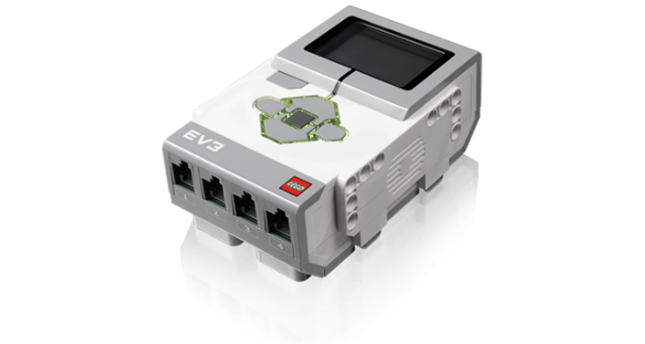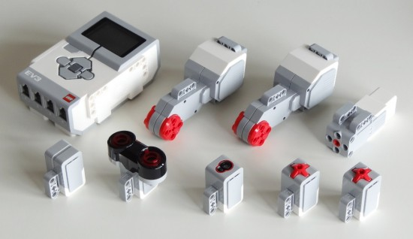

Figure 1: Lego Mindstorms EV3 Brick Figure 2: Lego Mindstorms Components

To find a list of the motors and sensors, look at Appendix A.

Before you start working with this box, look carefully at the picture on the top. This picture shows the components that should be placed in the top compartment. Keep in mind that this box roughly costs **€ 450**,-. It is **your responsibility** as a group, to keep the brick, motors and sensors together. If you are missing one or more of these components, your group has to reimburse them.

# Assignment (Drive system)

The Drive system makes sure that the robot can reach its destination, but how is this achieved? Let’s have a closer look at how it works. In the box you will find three motors. The small motor is used for picking up. The two big motors are being used for driving. Your robot is required to steer and move using these motors. Before you start building the solution given in this document, look at the big motors and think about how you can drive and steer the robot with these parts. Draw/write your answer below:

|  |
| --- |
| For the drive system we think that we will use the two big motors for steering and also moving forward and backwards . We will place them in the front each motor attached to its own wheel for a total of two front wheels . Since the two front wheels will be handling the steering and the movement in the back we will just have ball or very small wheels that is just there to balance the back and goes along with the movements of the two front wheels. |

Q. 1

Before you continue reading here, make sure you have answered [**Q.1**](#_Assignment_(Drive_system)) above.

Now that you have thought about a solution, let’s look at the given solution. In the figure below, you see the solution you are going to build today. The two big motors are placed next to each other. Connected to these motors are big wheels. In the front a ball that can rotate in all directions, allows for steering. When the wheels rotate the same direction, the robot moves forward/back (dependent on the direction). When the wheels rotate in opposite directions of each other, the robot rotates in the direction of the reversing wheel. If one wheel stops (or rotates slow) and the other rotates (faster), the robot steers in the direction of the stopped (or slower) wheel.

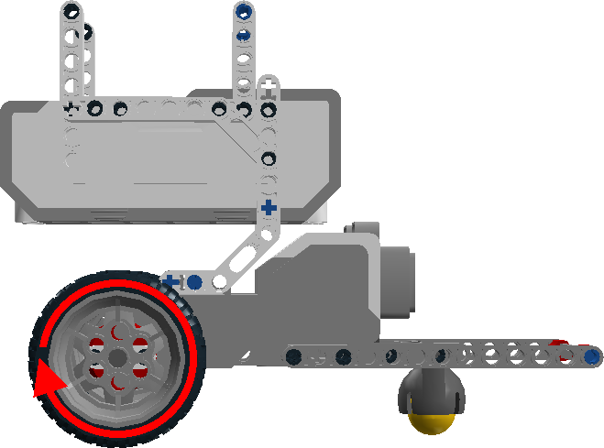

Figure 3: Drive system (How it works)

You can now start following the tutorial found on [Sharepoint](https://portal.fhict.nl/es/FIS2/Week%202/Resources/Building%20Instructions%20%5bDriver%5d.rar) (TIP: use both the HTML as LEGO Digital Designer tutorials!). When you are done, continue with chapter “Using the motor(s)”.

# Assignment (Pickup system)

The Pickup system makes sure the object is picked up; let us have a closer look at how it works. In the box you will find three motors. The two big motors are being used for driving. The only motor that is left is the small motor. You have to use it for the entire pick process, which means you have a challenge. The robot needs to be able to **grab** and **lift** an object in order to transport it to its destination. This means you need two separate movements with one motor.

Before you continue to the existing solution, take some time to think about how you would solve this challenge and draw/write your answer below:

|  |
| --- |
| Since well only have one motor to work with I think the best option would be to work with gears so that when the small motor is activated a call first closes and the goes up and we achieve this with the use of gears. And when you want to put down the object it goes in the opposite direction so the claw first goes down then releases the object. |

Now that you have thought about a solution, let’s look at the given solution. In the figure below, you see the result what you are going to build today. The motor on the left upper corner rotates a small gear. This small gear rotates a big gear that will turn the connected arm. When the arm moves backwards (at 1 & 2), the red angled beam (at 1) will move which activates the grey gears below it to close the grab mechanism (details will be visible in the tutorial when building). When the grab mechanism can’t close further, the continuing pull on the red angled beam will force the lower beam (at 2) to lift upwards. This results in the required two stages: 1. Grab; 2. Lift.

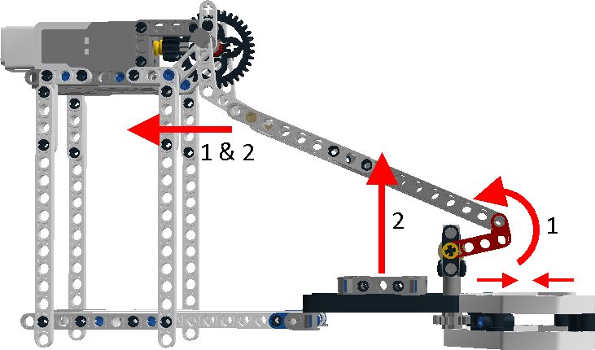

Figure 4: Pick system (How it works)

You can now start following the tutorial found on [Sharepoint](https://portal.fhict.nl/es/FIS2/Week%202/Resources/Building%20Instructions%20%5bGrabberWithFrame%5d.rar) (TIP: use both the HTML as LEGO Digital Designer tutorials!).. When you are done, continue with chapter “Using the motor(s)”.

# Using the motor(s)

Your system is finished, but it does not do a lot. If you want it to work, the motors have to be connected to the brick. So let’s have another look at the brick again.

Figure 5: Lego Mindstorms Components

NOTE: You have 1 brick for two pairs. Decide together on a schedule. Both pairs need to use the brick to test and run the programs created.

In Figure 5 you can see four ports at the bottom. Four similar ports can be found on the top. The ports on the top marked “A,B,C and D” are for the motors, while the ports on the bottom “1, 2, 3 and 4” are marked for sensors (more on this later).

Now connect your motors to the brick and use the tutorials of the Lego Mindstorms IDE to make the parts of your robot to move. Depending on which part of the system you worked on you need to implement the following:

|  |  |
| --- | --- |
| **Robot** | |
| Pair 1 (Drive system) | Pair 2 (Pickup system) |
|  | C:\Users\888602\Dropbox\FIS\Sharepoint\Block 2\Practical\Robot assignment\Grabber With Frame.png |
| The motor of the drive system should rotate the wheels in such a way it can go forward, left and right. | The motor of the pickup system should closes the grab mechanism and and lift the entire ‘arm’ up. |

TIP: See appendix C for information about the Lego Mindstorms IDE.

# Perceiving the world.

Congratulations, you have finished your system. When connecting the motor(s) to the brick, it will be possible for you to program it. But how will your robot know where it has to go? How will your robot know if it can start picking the product up? Let’s presume the robot needs to be able to follow the predefined track in appendix B; how would it do that?

The answer is sensors. In your box you will find five sensors: Two touch sensors, an ultrasonic sensor, colour sensor and gyro sensor. In order to keep the entire robot in mind (both systems), switch partners to shape the same pair as week one. Now both pairs should have a drive system expert and a pick system expert. Discuss with your new partner which sensors are needed for your robot and where they should be placed. Draw/write your answer below:

|  |
| --- |
| We will use all of the sensors except for the gyro sensor .  The touch sensors will be used to detect collision and set off an emergency stop if necessary.  Ultrasonic sensor is going to be used to detect the container that needs to be transported .  And the colour sensor will be used to detect the path that needs to be followed. |

# Appendix A: Motors & Sensors

|  |  |  |
| --- | --- | --- |
| Name | Amount | Description |
| Big motor | 2× | Can rotate, in the tutorial used for propelling the wheels. |
| Small motor | 1× | Can rotate (faster, less strong) in the tutorial used for other movement. |
| Pressure sensor | 2× | Used to detect collision with objects. |
| Ultrasonic sensor | 1× | Used to detect distance to objects. |
| Colour sensor | 1× | Used for colour (eight colours) and ambient light detection. |
| Gyro sensor | 1× | Used to detect rotation. |

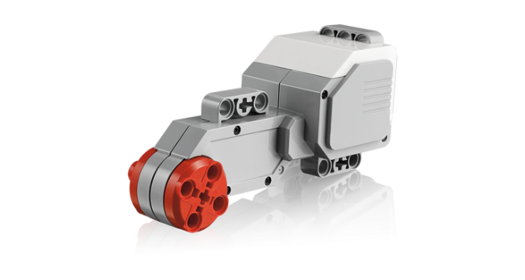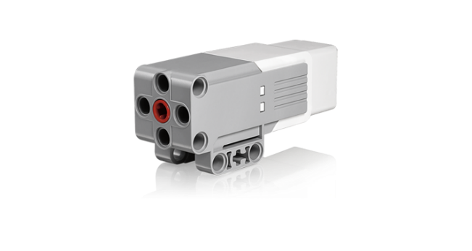

Big motor Small motor

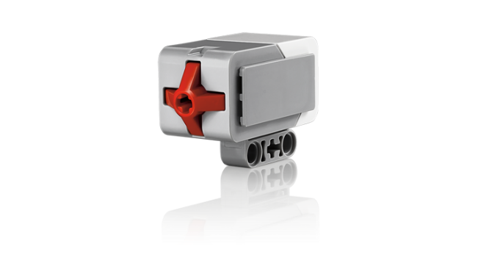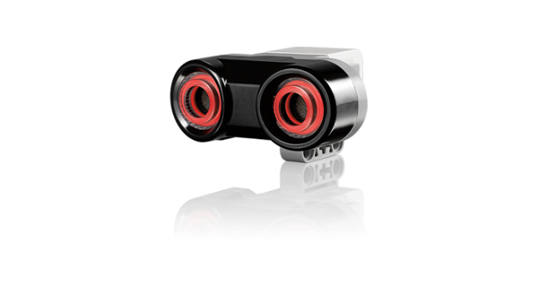

Touch sensor Ultrasonic sensor

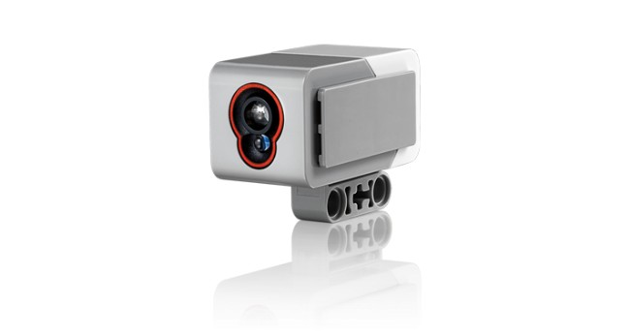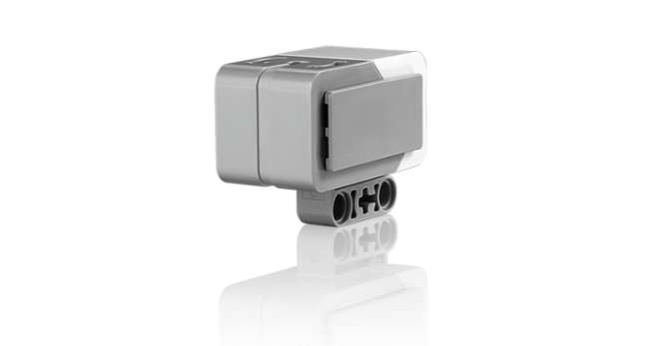

Colour sensor Gyro sensor

# Appendix B: Track

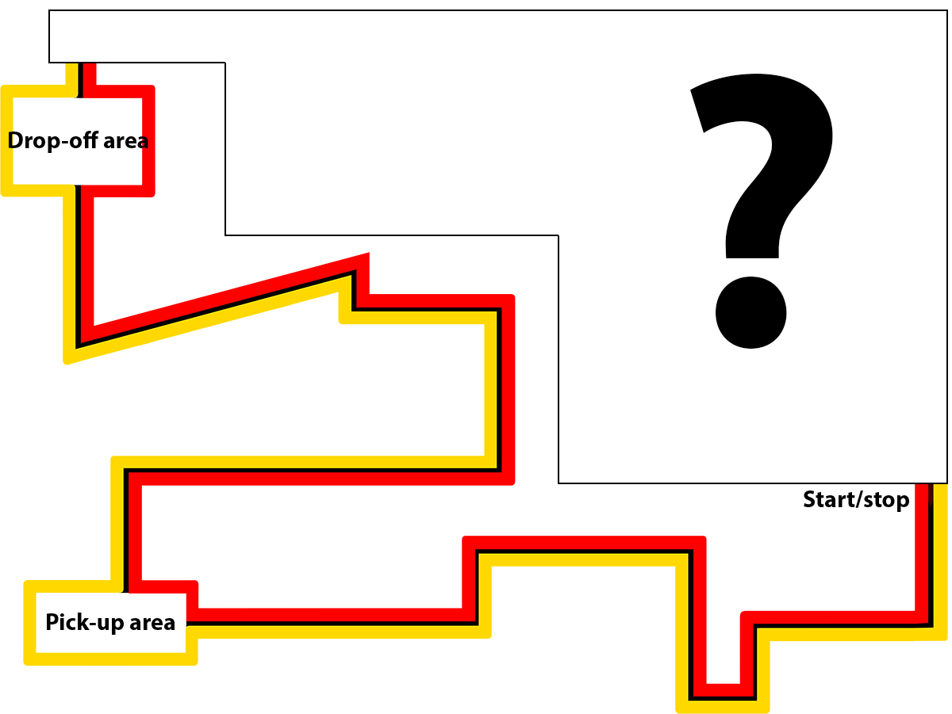

# Appendix C: Lego Mindstorms IDE

To be able to program for the brick you need to install the IDE of Lego Mindstorms. When you start this IDE you will see it doesn’t require you to write code. Instead you program visually by connected block together. Keep in mind the program you create works in an imperative way!

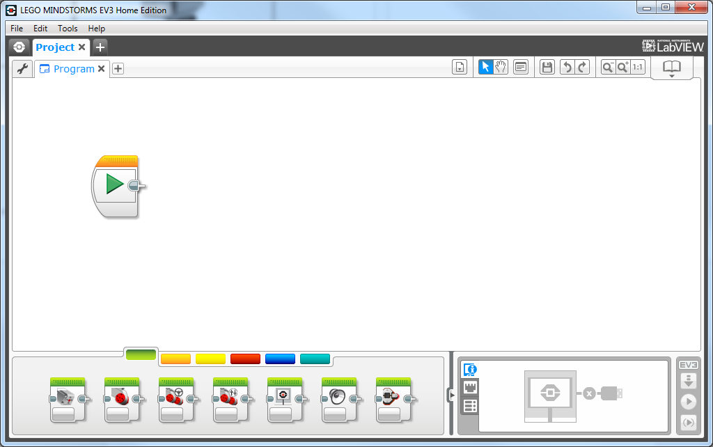

Figure 6: The IDE

There are different types of blocks available. These are divided in colored tabs. See the table below for a description of each tab.

|  |  |
| --- | --- |
| Color | Content |
| C:\Users\874156\Desktop\Untitled-3.jpg | *Action tab*  The blocks for ‘output’ is located here. These blocks ranges from letting a motor run to letting the Brick play a sound. |
| C:\Users\874156\Desktop\Untitled-3.jpg | *Flow control tab*  The blocks to create ‘program flow’ is found here. Some examples are while-loop and switch-statements. |
| C:\Users\874156\Desktop\Untitled-3.jpg | *Sensor tab*  The blocks for ‘input’ is located here. These block ranges from reading the sensors to buttons pressed on the Brick. |
| C:\Users\874156\Desktop\Untitled-3.jpg | *Data operations tab*  The block for working with ‘data’. Some examples are reading from a variable and comparing two values. |
| C:\Users\874156\Desktop\Untitled-3.jpg | *Advanced tab*  The blocks for creating more advanced features. These blocks ranges from sending/receive Bluetooth messages to access a file on the Brick. |
| C:\Users\874156\Desktop\Untitled-3.jpg | *My Blocks tab*  By default empty, but you can convert a project to a block. This block can be used in other projects. |

When you’re finished with your program and want to test it, you can connect the brick via the USB cable to your computer. By pressing the play button you can run the program on the brick.